# Analisis Model Data

## Entity Relationship Diagram

## C:\Users\IBM\Dropbox\File Kuliah\RPL\Tugas Besar\Bahan\10489202_10201757504050358_876555515_n.jpg

## Skema Relasi

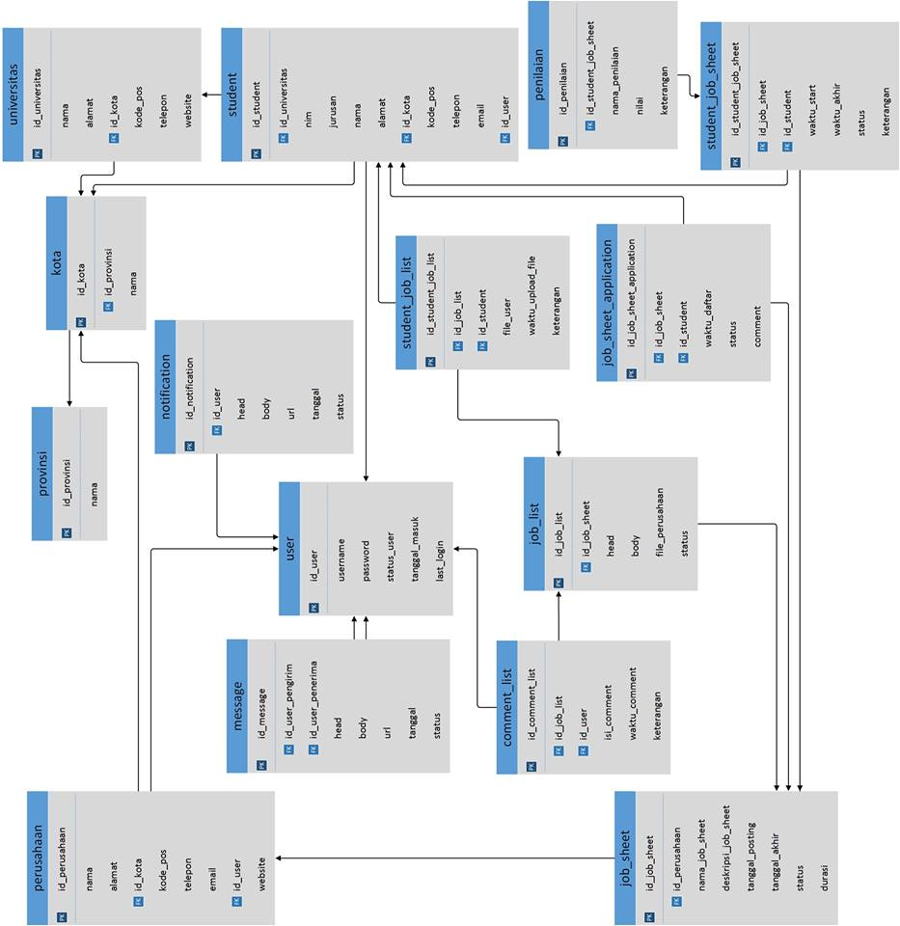

## 

## Kamus Data

|  |  |
| --- | --- |
| **Entitas** | **Atribut** |
| *t\_comment\_list* | id\_comment\_list, id\_job\_list, id\_user, isi\_comment, waktu\_comment |
| *t\_job\_list* | id\_job\_list, id\_job\_sheet, head, body, file\_perusahaan, status |
| *t\_job\_sheet* | id\_job\_sheet, id\_perusahaan, nama\_job\_sheet, deskripsi\_job\_sheet, tanggal\_posting, tanggal\_akhir, status, durasi |
| *t\_job\_sheet\_application* | id\_job\_sheet\_application, id\_job\_sheet, id\_student, application\_file, waktu\_daftar, status comment |
| t\_jurusan | id\_jurusan, nama |
| t\_kota | id\_kota, id\_provinsi, nama |
| *t\_message* | id\_message, id\_user\_pengirim, id\_user\_penerima, head, body, url, tanggal, status |
| *t\_notification* | id\_notification, id\_user, head, body, url, tanggal, status |
| t\_penilaian | id\_penilaian, Id\_user, disiplin, tanggap, cermat, rajin, komunikasi, keterangan |
| t\_perusahaan | id\_perusahaan, nama, alamat, id\_kota, kode\_pos, telepon, id\_user, website |
| t\_provinsi | id provinsi, nama |
| *t\_student* | id\_student, id\_universitas, nim, id\_jurusan, nama, alamat, id\_kota, kode\_pos, telepon, email, id\_user |
| *t\_student\_job\_list* | id\_student\_job\_list, Id\_job\_list, Id\_student, file\_user, waktu\_upload\_file, keterangan |
| *t\_student\_job\_sheet* | id\_student\_job\_sheet, id\_job\_sheet, id\_student, waktu\_start, waktu\_akhir, status, keterangan |
| t\_univesitas | id\_universitas, nama, alamat, id\_kota, kode\_pos, telepon, website |
| *t\_user* | id\_user, email, password, foto\_user, status\_user, tanggal\_masuk, last\_login |

## Struktur Tabel

1. t\_comment\_list

|  |  |  |  |  |  |
| --- | --- | --- | --- | --- | --- |
| **Nama Kolom** | **Tipe Data** | **Primary Key** | **Foreign Key** | **Null** | **Auto Increment** |
| id\_comment\_list | Int | Ya |  | Ya | Ya |
| id\_job\_list | Int |  | Ya |  |  |
| id\_user | Int |  | Ya |  |  |
| isi\_comment | Varchar(100) |  |  |  |  |
| waktu\_comment | datetime |  |  |  |  |

1. t\_job\_list

|  |  |  |  |  |  |
| --- | --- | --- | --- | --- | --- |
| **Nama Kolom** | **Tipe Data** | **Primary Key** | **Foreign Key** | **Null** | **Auto Increment** |
| id\_job\_list | Int | Ya |  | Ya | Ya |
| id\_job\_sheet | Int |  | Ya |  |  |
| Head | Varchar(100) |  |  |  |  |
| Body | Text |  |  |  |  |
| file\_perusahaan | Varchar(100) |  |  |  |  |
| status | Enum(‘1’,’0’) |  |  |  |  |

1. t\_job\_sheet

|  |  |  |  |  |  |
| --- | --- | --- | --- | --- | --- |
| **Nama Kolom** | **Tipe Data** | **Primary Key** | **Foreign Key** | **Null** | **Auto Increment** |
| id\_job\_sheet | Int | Ya |  | No | Ya |
| id\_perusahaan | Int |  | Ya |  |  |
| nama\_job\_sheet | Varchar(100) |  |  |  |  |
| deskripsi\_job\_sheet | Text |  |  |  |  |
| tanggal\_posting | Datetime |  |  |  |  |
| tanggal\_akhir | Datetime |  |  |  |  |
| Status | Enum(‘1’,’0’) |  |  |  |  |
| Durasi | Int |  |  |  |  |

1. job\_sheet\_application

|  |  |  |  |  |  |
| --- | --- | --- | --- | --- | --- |
| **Nama Kolom** | **Tipe Data** | **Primary Key** | **Foreign Key** | **Null** | **Auto Increment** |
| id\_job\_sheet\_application | Int | Ya |  | No | Ya |
| id\_job\_sheet | Int |  | Ya |  |  |
| id\_student | Int |  | Ya |  |  |
| application\_file | Varchar(100) |  |  |  |  |
| waktu\_daftar | Datetime |  |  |  |  |
| Status | Enum(‘1’,’0’) |  |  |  |  |
| comment | Varchar(100) |  |  |  |  |

1. t\_jurusan

|  |  |  |  |  |  |
| --- | --- | --- | --- | --- | --- |
| **Nama Kolom** | **Tipe Data** | **Primary Key** | **Foreign Key** | **Null** | **Auto Increment** |
| id\_jurusan | Int | Ya |  | No | Ya |
| Nama | Varchar(50) |  |  | No |  |

1. t\_kota

|  |  |  |  |  |  |
| --- | --- | --- | --- | --- | --- |
| **Nama Kolom** | **Tipe Data** | **Primary Key** | **Foreign Key** | **Null** | **Auto Increment** |
| id\_kota | Int | Ya |  | No | Ya |
| id\_provinsi | Int |  | Ya | No |  |
| Nama | Varchar(25) |  |  | No |  |

1. t\_message

|  |  |  |  |  |  |
| --- | --- | --- | --- | --- | --- |
| **Nama Kolom** | **Tipe Data** | **Primary Key** | **Foreign Key** | **Null** | **Auto Increment** |
| id\_message | Int | Ya |  | No | Ya |
| id\_user\_pengirim | Int |  | Ya |  |  |
| id\_user\_penerima | Int |  | Ya |  |  |
| Head | Varchar(100) |  |  |  |  |
| Body | Text |  |  |  |  |
| url | Varchar(100) |  |  |  |  |
| Tanggal | Datetime |  |  |  |  |
| Status | Enum(‘1’,’0’) |  |  |  |  |

1. t\_notification

|  |  |  |  |  |  |
| --- | --- | --- | --- | --- | --- |
| **Nama Kolom** | **Tipe Data** | **Primary Key** | **Foreign Key** | **Null** | **Auto Increment** |
| id\_notification | Int | Ya |  | No | Ya |
| id\_user | Int |  | Ya |  |  |
| Head | Varchar(100) |  |  |  |  |
| Body | Text |  |  |  |  |
| url | Varchar(100) |  |  |  |  |
| Tanggal | Datetime |  |  |  |  |
| Status | Enum(‘1’,’0’) |  |  |  |  |

1. t\_penilaian

|  |  |  |  |  |  |
| --- | --- | --- | --- | --- | --- |
| **Nama Kolom** | **Tipe Data** | **Primary Key** | **Foreign Key** | **Null** | **Auto Increment** |
| id\_penilaian | Int | Ya |  |  | Ya |
| Id\_user | Int |  | Ya |  |  |
| Disiplin | Int |  |  |  |  |
| Tanggap | Int |  |  |  |  |
| Cermat | Int |  |  |  |  |
| Rajin | Int |  |  |  |  |
| komunikasi | Int |  |  |  |  |
| keterangan | Varchar(100) |  |  | Ya |  |

1. t\_perusahaan

|  |  |  |  |  |  |
| --- | --- | --- | --- | --- | --- |
| **Nama Kolom** | **Tipe Data** | **Primary Key** | **Foreign Key** | **Null** | **Auto Increment** |
| id\_perusahaan | Int | Ya |  |  | Ya |
| Nama | Varchar(50) |  |  |  |  |
| Alamat | Text |  |  |  |  |
| id\_kota | Int |  | Ya | Ya |  |
| kode\_pos | Varchar(6) |  |  |  |  |
| Telepon | Varchar(13) |  |  |  |  |
| id\_user | int |  | Ya |  |  |
| Website | Varchar(50) |  |  | Ya |  |

1. t\_provinsi

|  |  |  |  |  |  |
| --- | --- | --- | --- | --- | --- |
| **Nama Kolom** | **Tipe Data** | **Primary Key** | **Foreign Key** | **Null** | **Auto Increment** |
| id\_provinsi | Int | Ya |  | No | Ya |
| Nama | varchar(25) |  |  | Ya |  |

1. t\_student

|  |  |  |  |  |  |
| --- | --- | --- | --- | --- | --- |
| **Nama Kolom** | **Tipe Data** | **Primary Key** | **Foreign Key** | **Null** | **Auto Increment** |
| id\_student | Int | Ya |  | No | Ya |
| id\_universitas | Int |  | Ya |  |  |
| Nim | Varchar(12) |  |  |  |  |
| id\_jurusan | Varchar(25) |  |  |  |  |
| Nama | Varchar(50) |  |  |  |  |
| Alamat | Text |  |  |  |  |
| id\_kota | Int |  | Ya |  |  |
| kode\_pos | Varchar(6) |  |  |  |  |
| Telepon | Varchar(13) |  |  |  |  |
| Email | Varchar(50) |  |  |  |  |
| id\_user | Int |  | Ya |  |  |

1. t\_student\_job\_list

|  |  |  |  |  |  |
| --- | --- | --- | --- | --- | --- |
| **Nama Kolom** | **Tipe Data** | **Primary Key** | **Foreign Key** | **Null** | **Auto Increment** |
| id\_student\_job\_list | Int | Ya |  | No | Ya |
| Id\_job\_list | Int |  | Ya |  |  |
| Id\_student | Int |  | Ya |  |  |
| file\_user | Varchar(100) |  |  |  |  |
| waktu\_upload\_file | Datetime |  |  |  |  |
| Keterangan | Varchar(100) |  |  |  |  |

1. t\_student\_job\_sheet

|  |  |  |  |  |  |
| --- | --- | --- | --- | --- | --- |
| **Nama Kolom** | **Tipe Data** | **Primary Key** | **Foreign Key** | **Null** | **Auto Increment** |
| id\_student\_job\_sheet | Int | Ya |  | No | Ya |
| id\_job\_sheet | Int |  | Ya |  |  |
| id\_student | Int |  | Ya |  |  |
| waktu\_start | Datetime |  |  |  |  |
| waktu\_akhir | Datetime |  |  |  |  |
| Status | Enum(‘1’,’0’) |  |  |  |  |
| keterangan | Varchar(100) |  |  |  |  |

1. t\_univesitas

|  |  |  |  |  |  |
| --- | --- | --- | --- | --- | --- |
| **Nama Kolom** | **Tipe Data** | **Primary Key** | **Foreign Key** | **Null** | **Auto Increment** |
| id\_universitas | Int | Ya |  | No | Ya |
| Nama | Varchar(50) |  |  |  |  |
| Alamat | Text |  | Ya |  |  |
| id\_kota | Int |  |  |  |  |
| kode\_pos | Varchar (6) |  |  |  |  |
| Telepon | Varchar(100) |  |  |  |  |
| Website | Varchar(50) |  |  |  |  |

1. t\_user

|  |  |  |  |  |  |
| --- | --- | --- | --- | --- | --- |
| **Nama Kolom** | **Tipe Data** | **Primary Key** | **Foreign Key** | **Null** | **Auto Increment** |
| id\_user | Int | Ya |  | No | Ya |
| Email | Varchar (50) |  |  | No |  |
| password | Varchar (50) |  |  | No |  |
| foto\_user | Varchar(150) |  |  |  |  |
| status\_user | Enum(‘COMPANY’,’STUDENT’,’ADMIN’) |  |  |  |  |
| tanggal\_masuk | Datetime |  |  |  |  |
| last\_login | Datetime |  |  |  |  |